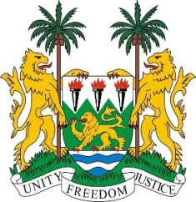
SIERRA LEONE
24th Session of the UPR

SINGAPORE

27 January 2016

Mr President,

Sierra Leone warmly welcomes the high-level delegation of Singapore and thanks them for their oral update.

My delegation commends the Government of Singapore for consistently promoting human rights as evidenced by the various policies relating to the trafficking in persons, including the National Plan of Action against Trafficking in Persons, and Singapore’s accession in 2015 to the UN TIP Protocol. Similarly, we note with interest that Singapore intends to accede to the ICERD in 2017.

It is noteworthy that Singapore celebrated its fifth decade as an independent State last year, and that the country enjoys a stable economy with over 90% of its citizens owning their own homes, and that 20% of the government’s annual expenditure in 2014 was dedicated to education. Furthermore, Singapore has consistently contributed financially to the OHCHR since 2011.

My delegation would however encourage Singapore to incorporate into its national legislation, a clear definition of all forms of discrimination against women in order to bring it in line with the provisions of the CEDAW.

Recommendations:

- Sign and ratify the core international instruments including the ICRMW, CAT, ICPPED and ICPPR.
- Re-establish a moratorium with a view to abolishing the death penalty.

Finally, Sierra Leone wishes Singapore a successful review.

Thank you, Mr President.

